DIDACTICAE | Universitat de Barcelona | ISSN 2462-2737 |

**Manuscript title**  
[Verdana, size 12, bold, lowercase, left-aligned]

|  |  |  |
| --- | --- | --- |
|  |  |  |

**Abstract**: The abstract should present a concise summary of the text in no more than 200 words. The typography for this section is Times New Roman, size 11, justified, with 1.15 line spacing. The abstract will appear below translated into Spanish. Its translation into Catalan will be provided by the Editorial Board.

**Keywords**: keyword; keyword; keyword.   
[from 3 to 5 keywords max., between colons, Verdana, size 9, left-aligned, 1.15 line spacing, no capitals, full stop at the end]

***TITLE IN SPANISH IN CAPITALS AND ITALICS***

[Georgia, bold, italics, size 9.5, left-aligned]

***Resumen:*** *El resumen presenta el artículo de modo conciso en no más de 200 palabras.* [Georgia, size 9.5, italics, justified, line spacing 1.15]

***Palabras clave:*** *palabra clave; palabra clave; palabra clave.*

[from 3 to 5 keywords max., between colons, Georgia, size 9.5, left-aligned, 1.15 line spacing, no capitals, full stop at the end]

**Introduction** [section titles in Verdana, bold, size 10]

Texts will have the following length (without references): articles and monographic articles, between 4000 and 8000; history and epistemology, between 4000 and 9000; innovation and experiences, between 3000 and 6000; book, projects and thesis reviews, between 1000 and 1500. In order to facilitate the edition of the journal, we request that you follow the instructions contained in this document. The maximum number of pages will be, in any case, 17 pages. The easiest way to do so is by using this document as a template and replacing its contents.

For the text body, use Verdana, size 9. The text should be justified and have 1.5 line spacing. As you can see above, the first paragraph of each section is not indented. The other, subsequent paragraphs should indent the first line by 1.25. One should avoid footnotes as much as possible. Only if deemed essential, the “insert footnote” tool should be used[1].

No space will be left between paragraphs within each section. One blank space must be left before writing the title of the next section, though.

**1. First section margins** [section titles in Verdana, bold, size 10]

After the introduction, each section will be numbered, except for “Introduction”, “Conclusion”, “Acknowledgements” and “References”.

The margins of the document should be as follows: upper 2 cm, inferior 2.5 cm, left 3.5 cm and right 2.5 cm.

**1.1 First subsection: anonymity** [subsections in Verdana, bold, size 9]

So as to guarantee the anonymity in the evaluation process, the text shall not contain any reference which could reveal the author(s)’ identity, except in the list of references. The acknowledgements, if any, will be added once the article has been accepted for publication.

**1.2 Second subsection: quotes**

All quotes should appear in round font, except those included in a language that does not coincide with that of the main text, and in that case, should be in italics.

Conceptual quotes should conclude with the author’s surname and the year of publication, ordered alphabetically (Surname, 2017; Surname & Surname, 2017; Surname et al., 2018). Textual quotes “should appear between quotation marks and the number of the corresponding page will be added after the year” (Surname & Surname, 2017, pp. 30-31). Longer quotes, that is, more than two lines long, should appear in a separate paragraph following these instructions:

Example of quote longer than two lines that should appear in a separate paragraph. The typography for such quotes should be Verdana, size 8, a smaller size than that of the main body of the text. The quote should be justified with a line spacing of 1.15. The longer quote will have a 1.25cm indention both on the left and on the right. (Surname et al., 2017, p. 30)

***1.2.1 Third subsection***

The number of the third sublevel must not finish with a full stop. It appears in Verdana, size 9, bold and italics. Use this third level only if strictly necessary.

**2. Second section: images and tables**

The quality of all images (illustrations, photographs, tables, pictures…) included needs to be high enough for optimal reproduction. The images will be inserted in this document where the author wants them to appear. The text in the tables will also be in Verdana, like the text main body. Once the article is accepted for publication, all images will be sent in jpg, eps or tiff format with a 300 dps resolution.

The authors are responsible for copyright management. The location of the images should appear in the text within parenthesis, like this (Figure 1/Table 1). All the images need to be numbered. The images should be centred and reference the author and copyright. There needs to be a blank space between the image and the paragraphs both above and below.

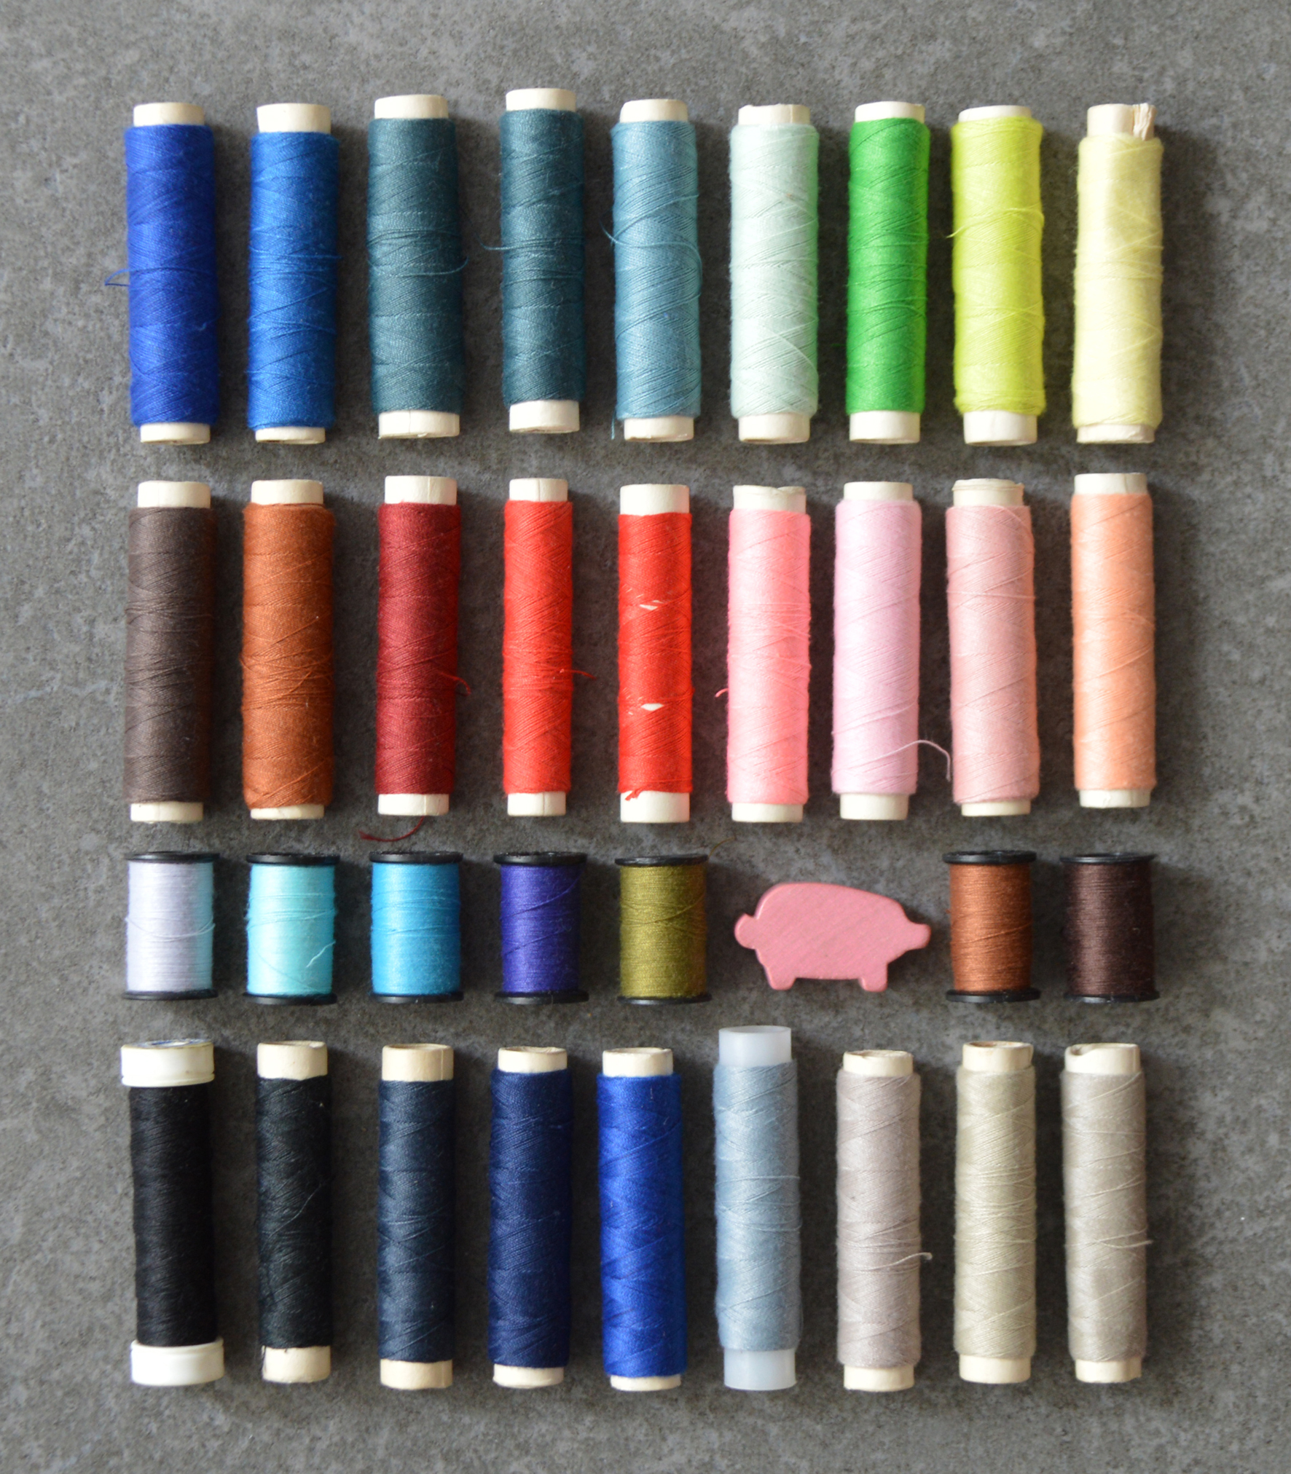

Figure 1. Georgia, size 8, centred,line-spacing 1.15.   
Cover image of the first issue of *Didacticae*.

**References**

Bibliographical references should follow the current APA citation format. Georgia, size 9.5, 1.15 spacing, French indention (hanging). For example:

**Books and journal articles on paper**

Surname, N. (year). Title of the article. *Name of the Journal Capitalized, 12*(2), 9-17.

Surname, N. (year). *Book title in italics, no caps* (5th ed.)*.* Publisher.

Surname, N., & Surname, N. (year). *Book title: Subtitle* (2nd ed.)*.* Publisher.

Surname, N., Surname, N., & Surname, N. (year). *Book title in italics, no caps* (3rd ed.)*.* Publisher.

Surname, N. (year). Chapter title: Subtitle. In N. Surname, N. Surname & N. Surname (Eds./Coords.), *Book title in italics, no caps: Subtitle* (3rd ed., pp. 15-30)*.* Publisher.

Name of institution or corporative author group. (year). *Title in italics, no caps: Subtitle.* (4th ed.). Publisher.

*Title of book by anonymous author in italics no caps* (2nd ed.). (year). Publisher.

**Electronic books and book chapters**

* ***With DOI***

Surname, N. (year). *Title in italics, no caps: Subtitle*. <https://doi.org/xx.xxxxxo> ##.####/###########

The DOI is not followed by a period. DOI preferred over url.

* ***Without DOI***

Surname, N. (year). *Title in italics, no caps: Subtitle*. url

Surname, N. (year). Chapter title: Subtitle. In N. Surname, N. Surname & N. Surname (Eds.), *Book title in italics, no caps: Subtitle* (3rd ed., pp. 5-25). https://doi.org/xx.xxxxx// url

URLs are not followed by a full stop.

**Papers in electronic journals**

* ***With DOI***

Surname, N., & Surname, N. (year). Title of article: Subtitle. *Journal Title in Italics and Caps: Subtitle*, *13*(3), 15-20. https://doi.org/xx.xxxxx

* ***Without DOI (url)***

Surname, N., Surname, N., & Surname, N. (year). Title of the article: Subtitle. *Journal Title in Italics and Caps, 12*(3), 15-30. url

If a paper appears in an issue without volume, skip the volume in italics and write the issue within parenthesis.

**Encyclopedias, dictionaries**

* ***Epigraphs from encyclopedias, dictionaries, etc. on paper***
  + ***Known author***

Surname, N. (year). Epigraph title. In *Dictionary or encyclopedia title in italics, no caps*. (Vol. 3, pp. 15-20). Publisher.

* + ***Unknown author***

Epigraph title. (year). In *Enciclyopedia or Dictionary title in italics, no caps*. (Vol. 2, pp. 15-16). Publisher.

* ***Epigraphs from electronic encyclopedias, dictionaries, etc.***
  + ***Known author***

Surname, N. (year). Epigraph title. In N. Surname (Ed.), *Dictionary or encyclopedia title in italics, no caps*. (2nd ed.). url

* + ***Unknown author***

Epigraph title. (year). In *Dictionary or Encyclopedia title in italics, no caps* (3rd ed.). url

If the reference finishes with a DOI or a url, don’t add a full stop at the end. DOI preferred over url.

**Unpublished papers**

* ***In preparation***

Surname, N., & Surname, N. (date). Title of article: Subtitle. Manuscript in preparation.

* The date is the year when the paper was created.

* ***Articles submitted***

Surname, N., & Surname, N. (date). Title of article: Subtitle. Manuscript submitted for publications.

* The date is the year when the article was written.

* Don’t state the journal where the article has been submitted until accepted.

* ***Papers accepted (in press)***

Surname, N., & Surname, N. (in press). Title of article: Subtitle. *Journal Title in Italics and Capitalized: Subtitle*.

*No year

**Newspaper items**

* ***Newspaper items on paper***

Surname, N. (Day Month Year. Title of news item: Subtitle. *Newspaper Title in Italics: Subtitle*, pp. 13-15.

* ***Items in electronic newspaper***

Surname, N. (Day Month Year). Title of article: Subtitle. *Newspaper Title in Italics: Subtitle*. url

**PhD dissertations and Master’s thesis**

* ***On paper***
  + ***Published in a catalog***

Surname, N. (year). Title: Subtitle. *Catalog name in italics, volume in italics*(#), page.

* + ***Unpublished***

Surname, N. (year). *Title in italics, no caps: Subtitle* [Unpublished PhD dissertation, Name of institution].

* ***Electronic PhD dissertations and master’s thesis***

Surname, N. (year). *Title in italics, no caps* [Doctoral dissertation or Master’s Thesis, Name of institution]. Name of Database. (access #) / url

**Conference proceedings**

* ***Conference proceedings published as book***

Surname, N. (year). Paper title: Subtitle. In N. Surname (Ed.), *Conference Title in Italics and Capitalized: Subtitle* (p. 15-20). https://doi.org/xx.xxxxx

* ***Conference proceedings published regularly online***

Surname, N. (year). Title of the article: Subtitle. *Conference Name in Italics and Capitalized: Subtitle*, *# volume in italics* (pp 19-20). https://doi.org/xx.xxxxx

* ***Paper in a conference***

Surname, N. (month year). Contribution title. In N. Surname (Coord.), *Conference Name in Italics and Capitalized*. Conference held in City.

* ***Paper summary retrieved online***

Surname, N. (month year). *Title of paper in italics*. Paper presented at Name of Conference. City. Summary retrieved from url

**Norms**

Author. (year). *Title in italics, no caps: Subtitle* (# ed.). City: Publisher.

**Patents**

Surname, N. (year). *Patent number in italics*. City: Official patent source.

**Legislation**

Title of law, Name of official publication, #. Publication § section (year published).

**Websites**

* ***To cite any website, we will just provide the url. No need to include it in the references list. For example:***

Website name is a relevant site (url).

* ***When citing a specific website***

Author. (date). Website title. url

* ***Unknown author, title occupies its position.***

Website name. (Date). Retrieved from url

The date should always include day, month and year. If unknown, then indicate (n.d.).

For pages that change regularly, indicate the day when last retrieved:

Author. (month year). Website name. Last retrieved day, month, year from url

**Social networks. Electronic messages**

* ***Messages in newsletters or forums***

Sender’s surname, N. (message date). Title of message: Subtitle [Comment on an online forum]. url

* ***Messages on distribution lists***

Sender’s surname, N. (message date). Title of message: Subtitle [Message on distribution list]. url

* ***Blog post***

Surname, N. (date). Title of blog entry [Blog entry]. url

* ***Tweet***

Surname, N. [alias]. (date). Text of tweet up to 40 words [Tweet]. url

* ***Post on Facebook***

Surname, N. [Full name]. (date). Text of message up to 40 words [Type of entry]. url

* ***Post on Google+***

Surname, N. [Full name]. (date). Text of message up to 40 words [Type of entry]. url

* ***Personal e-mails***

No need to include them in the reference list. Cite them only within the text N. Surname (personal communication, date)

**Audio recordings**

Composer’s surname, N. (*copyright* year). Song Title Capitalized [Recorded by artist’s

N. Surname if different from composer’s]. On *Album Title in Italics Capitalized* [Type: CD, Disc, DVD, etc.]. City: Label. (Recording date if different from that of *copyright*)

**Movies, videos and DVD**

Producer’s surname, N. (producer), & Directors’ Surname, N. (dir.). (year). *Title in Italics with Capitals* [Type]. Country: Recording studio.

**Videos (YouTube, Vimeo, etc.)**

Surname, N. (date). Video Title [Video]. url

**Reports**

Surname, N. (year). *Title in italics, no caps: Subtitle* (Report n. xxx). City: Publisher.

Surname, N. (year). *Title in italics, no caps: Subtitle* (Report n. xxx). url

**Research data**

Surname, N. (year). Title [Resource type]. https://doi.org/xx.xxxxx

**Manuscripts, unpublished work or published informally**

Surname, N. (year). *Title in italics, no caps: Subtitle*. Unpublished manuscript [ or “Manuscript submitted for publication” or “Manuscript in progress”], Institution name, City / url

**Figures**

Elements: author/s, year, title and type of material (image, photograph, graphs…)

1. Footnotes in Verdana, size 7, left-aligned and space-line 1.